**Lesson 4 Demo 5**

**Create a Branch in Git**



Steps to be followed:

1. Create a new repository
2. Clone the GitHub repository
3. List all the branches in your repository
4. Create a new branch
5. Verify the creation of the new branch
6. Rename an existing branch
7. Delete the branch
8. Verify the deletion of the branch

**Step 1: Create a new GitHub repository**

1.1 Open the browser in your lab, go to **github.com,** and log in to your account

1.2 Click on the **+** icon from the upper-right corner of the page, and select **New repository** from the drop-down menu and then create a new repository



**Step 2: Clone the GitHub repository**

2.1 Open the browser in your lab, Go to **github.com,** and log in to your account

2.2 Open the **projectfile** repositry, and click on the **Code** button

2.3 Click on the icon as shown in the following screenshot to copy the **URL** provided under **HTTPS**



2.4 Open the **Terminal** tab on your lab, and use the following command to clone the repository:

**git clone URL**

**Note:** Replace URL with the copied URL from the repository

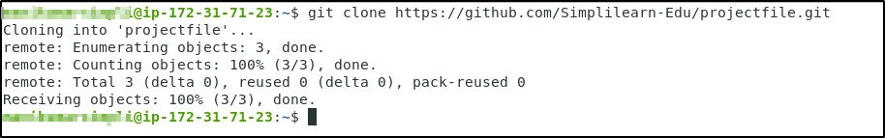

**Step 3: List all the branches in your repository**

3.1 Open the Terminal in your lab, and navigate to the **projectfile** folder

**cd projectfile**

3.2 Use the following command to list all the branches in your repository:

***git branch***

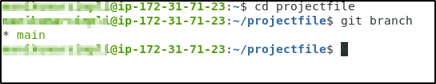

**Step 4: Create a new branch**

4.1 Run the following command to create a new branch in your repository:

***git branch new_branch***

**Step 5: Verify the creation of the new branch**

***git branch***

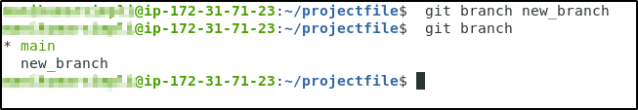

**Step 6: Rename an existing branch**

6.1 Use the following command to rename the new_branch:

***git branch -m new_branch1***

6.2 Use the following command to list the branches to verify the new name of the branch:

***git branch***

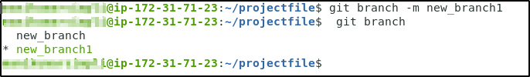

**Step 7: Delete the branch**

7. 1 Use the following command to delete the newly created branch:

***git branch -d new_branch***



**Step 8: Verify the deletion of the branch**

***git branch***

